34.53: a) The image from the objective is at the focal point of the eyepiece, so
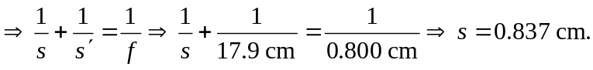
b) 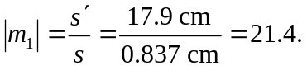
c) The overall magnification is 